cd\
cd xampp
cd mysql
cd bin
mysql –u root –p –h 127.0.0.1
1. Create a database named eemcDB
create database eemcDB;
show databases;
Output:
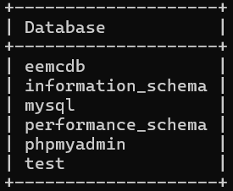

2. Create table named student_info database named eemcDB with following columns and datatypes.
Sid | Name | Contact | Faculty | College_Name
int | Varchar(50) | Char(10) | Varchar(50) | Varchar(50)

use database eemcDB;
create table student_info(Sid int, Name varchar(50), contact char(10), Faculty varchar(50), College_Name varchar(50));
describe student_info;
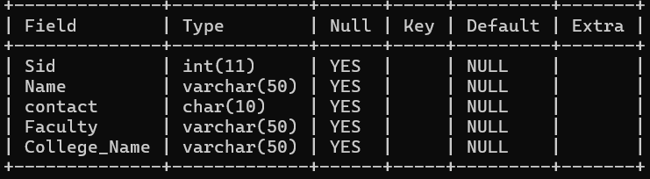
Output:

3. Now add column named address with datatype varchar(30).
ALTER TABLE student_info ADD COLUMN address varchar(30);
DESCRIBE student_info;
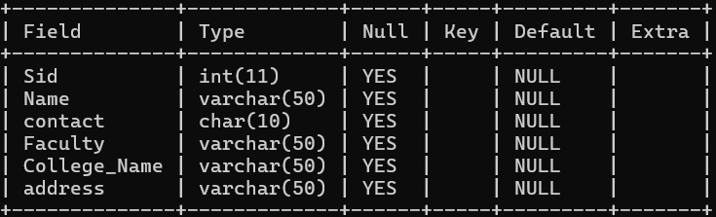
Output:

4. Delete the column named contact.
ALTER TABLE student_info DROP COLUMN contact;
DESCRIBE student_info;
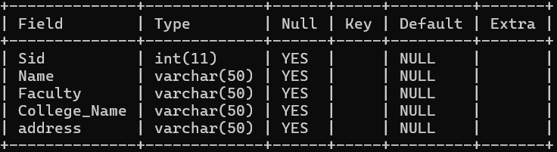
Output:

5. Rename column named address as location.
ALTER TABLE student_info CHANGE COLUMN address location varchar(50);
DESCIBE student_info;
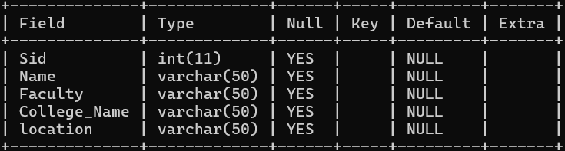
Output:

6. Change data type of faculty to char(20).
ALTER TABLE student_info MODIFY Faculty varchar(20);
DESCRIBE student_info;
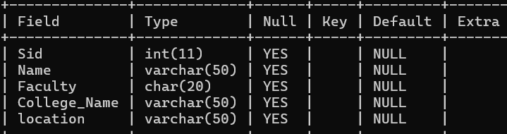
Output:

7. Insert minimum 10 information of student into table named student_info
✓ Insert 1 information of student whose faculty is not known
✓ Insert 1 information of student whose college_name is not known
INSERT into student_info (Sid, Name, Faculty, College_Name, address)
Values(1, 'Ram', 'civil', 'NCIT,'KTM'),
(2, 'shyam', 'computer', 'COSMOS','dang'),
(3, 'Hari', 'swoftware','NULL','chitwan'),
(4, 'Hari', 'NULL','EEC','Ilam'),
(5, 'Amin', 'IT','LEC','Jhapa'),
(6, 'Manish', 'LAW','NIST','Kavre'),
(7, 'Lalit', 'Computer science','KMC','Janakpur'),
(8, 'Dipendra', 'Arts','Xavier','Sudhurpasim'),
(9, 'Rohit', 'Diploma','KCCS','Lumbini'),
(10, 'Kushal', 'Humanities','EIC','Pokhara');
SELECT *from student_info;
Output:
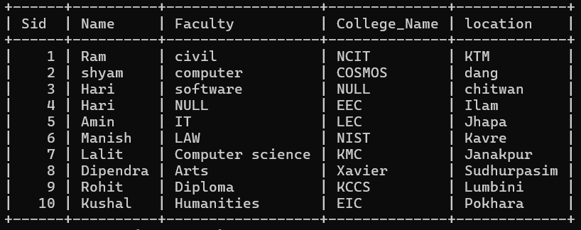

8. Update the information of student whose sid=3 by setting faculty =’civil’
UPDATE student_info set Faculty='civil' where Sid=3;
SELECT *from student_info;
Output:
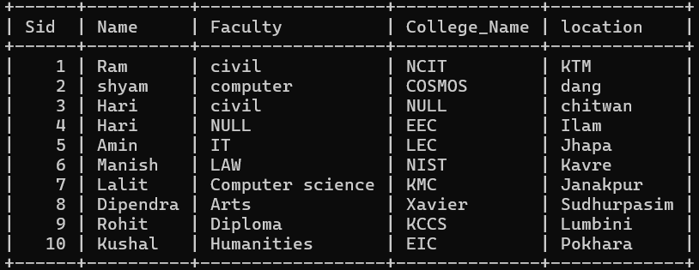

9.Update the information of student whose name is ‘ram’ and location is ‘kathmandu’ by setting faculty=’computer’.
UPDATE student_info set Faculty='Computer' where Name='Ram' and location='KTM';
SELECT *from student_info;
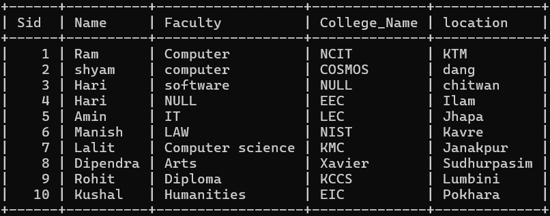
Output:

10.Delete the information of student whose faculty is Humanities and location is pokhara .
DELETE from student_info where Faculty='Humanities' and location='Pokhara';
SELECT *from student_info;
Output:
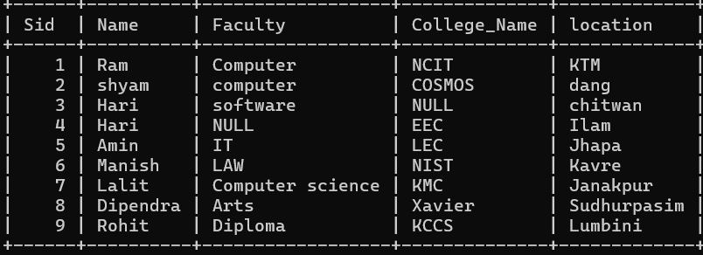

11. Display all the information of student from table named student_info.
SELECT *from student_info;
Output:

12.Display name and faculty of student whose location is Kathmandu.
SELECT Name,Faculty from student_info where location='KTM';
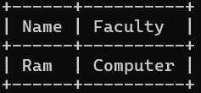
Output:

13.Display name and faculty of student whose location is Ilam and college_name is eemc.
SELECT Name,Faculty from student_info where location='Ilam'and College_Name='EEC';
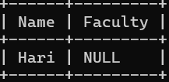
Output:

14. Delete all rows from table.
TRUNCATE table student_info;

15.Delete the table named student_info.
DROP TABLE student_info;

16.Delete the database named eemcDB.
DROP DATABASE eemcDB;

DISCUSSION:

